Exercise #4
on course “Cryptography ……”
topic: Rivest–Shamir–Adleman

Task

Realize Rivest–Shamir–Adleman algorithm.

RSA Algorithm
- Generating keys
- Choose two random distinct prime (простые) numbers, such as
p= 29, q=41

- Calculate n = p*q
n= p*q= 29*41=1189

- Applying Euler’s formula
Φ(n)= (p-1) (q-1) = 28*40=1120

- Choosing Public Key e randomly within certain bounds
e ∈ (1, Φ(n)), let e = 317

- Calculating Secret Key d. Applying Small Fermat’s theorem
e * d mod Φ(n) = 1 => d = e^(-1) mod(Φ(n))
d = 317^(-1) mod 1120 = 53

- Enciphering m-message with Public Key e
c(cyphered message) = m^{e} (mod n)
Let message to cypher be m = C[ASCII] = 67 => m = 67
c= 67^317 mod 1189 = 760 (it is in ASCI)
Transfer from ASCI: 760 mod 256 = 248 => [ASCII] => “ “

- Deciphering encrypted m-message with Secret Key d
c^{d} mod n = m^{ed} mod n
First transfer the symbol to ASCI
760^53 mod 1189 = 67=>[ASCII]=> “C”
67^(317*53) mod 1189 = 67=>[ASCII]=> “C”
Digital signature with RSA

- Generating keys
- Choose two random distinct prime (простые) numbers, such as
p= 29, q=41

- Calculate n = p*q
n= p*q= 29*41=1189

- Applying Euler’s formula
Φ(n)= (p-1) (q-1) = 28*40=1120

- Choosing Public Key e randomly within certain bounds
e ∈ (1, Φ(n)), let e = 317

- Calculating Secret Key d. Applying Small Fermat’s theorem
e * d mod Φ(n) = 1 => d = e^(-1) mod(Φ(n))
d = 317^(-1) mod 1120 = 53

- Creating Signature
s – crypted message
Let message to cypher be m = C[ASCII] = 67 => m = 67
s = m ^{d} mod n
67⁵³ mod 1189 = 486 =>[ASCII]=> “Ǧ” (H)

- Checking if the message is signed (checking signature)

VerifiedS = s^{e} mod n = 486³¹⁷ mod 1189 = 67 => [ASCII]=> “C”

Code listing:

import java.io.DataInputStream;
import java.io.IOException;
import java.math.BigInteger;
import java.util.Random;
public class RSA
{
private final BigInteger N;
private final BigInteger e;
private final BigInteger d;
public RSA()
{
Random r = new Random();
int maxLength = 1024;
BigInteger p = BigInteger.probablePrime(maxLength, r);
BigInteger q = BigInteger.probablePrime(maxLength, r);
N = p.multiply(q);
BigInteger PHI = p.subtract(BigInteger.ONE).multiply(q.subtract(BigInteger.ONE));
e = BigInteger.probablePrime(maxLength / 2, r);
while (PHI.gcd(e).compareTo(BigInteger.ONE) > 0 && e.compareTo(PHI) < 0)
{
e.add(BigInteger.ONE);
}
d = e.modInverse(PHI);
}
public static void main (String [] arguments) throws IOException
{
RSA rsa = new RSA();
DataInputStream input = new DataInputStream(System.in);
String inputString;
System.out.println("Enter message you wish to send:");
inputString = input.readLine();
System.out.println("Encrypting the message: " + inputString);
System.out.println("The message in bytes is: "
+ bytesToString(inputString.getBytes()));
// encryption
byte[] cipher = rsa.encryptMessage(inputString.getBytes());
// decryption
byte[] plain = rsa.decryptMessage(cipher);
System.out.println("Decrypting Bytes: " + bytesToString(plain));
System.out.println("Plain message is: " + new String(plain));
}
private static String bytesToString(byte[] cipher)
{
String temp = "";
for (byte b : cipher)
{
temp += Byte.toString(b);
}
return temp;
}
// Encrypting the message
public byte[] encryptMessage(byte[] message)
{
return (new BigInteger(message)).modPow(e, N).toByteArray();
}
// Decrypting the message
public byte[] decryptMessage(byte[] message)
{
return (new BigInteger(message)).modPow(d, N).toByteArray();
}
}
Results:

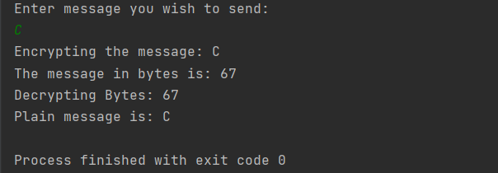

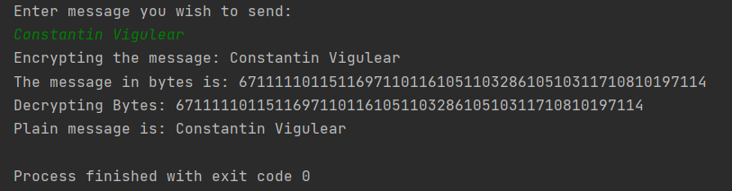
Conclusion:

Применив асимметричный алгоритм шифрования RSA, мне удалось зашифровать сообщение “C” вручную. В результате ручной расшифровки результат совпал с начальным словом. Результаты ручного вычисления совпали с результатами запрограммированного алгоритма, что подтверждает правильность ответа.
Bibliography:

Code: The Hidden Language of Computer Hardware and Software, Book by Charlez Petzold, Microsoft Press, October 23, 1999

Serious Cryptography: A Practical Introduction to Modern Encryption, Book by Jean-Philippe Aumasson, 2017

Cryptography, Book by Rubinstein-Salzedo Simon, 2018

Information Security, 2Ed: Principles And Practices, book by Mark Stamp, 2018

Introduction to Cryptography, Book by Sahadeo Padhye, Rajeev A.Sahu, Vishal Saraswat, 2018

